Nevada Opioid Crisis Needs Assessment
December 2018

Julie Kotchevar, PhD

Administrator

Division of Public and Behavioral Health

Ihsan Azzam, PhD, MD

Chief Medical Officer

Division of Public and Behavioral Health

Brian Sandoval

Governor

State of Nevada

Richard Whitley, MS

Director

Department of Health and Human Services

Division of Public and Behavioral Health

Opioid State Targeted Response to the Opioid Crisis Grant Program

Brian SandovalDivision of Public and Behavioral Health

Opioid State Targeted Response to the Opioid Crisis (Opioid STR) Grant Program

Acknowledgements
Prepared by and additional information:
Division of Public and Behavioral Health
State of Nevada
4126 Technology Way, Suite 201
Carson City, Nevada 89706
(775) 684.5895

Stephanie Woodard, PsyD
DHHS Senior Advisor on Behavioral Health
Opioid State Targeted Response Project Director
opioidstrgrant@health.nv.gov

Thank you to the following for providing leadership, data and technical support for this report:

Kyra Morgan, MS
Chief Biostatistician
Department of Health and Human Services
State of Nevada

Laurel Brock-Kline
Opioid Biostatistician II
Division of Public and Behavioral Health
State of Nevada
Jen Thompson
Health Program Specialist II
Division of Public and Behavioral Health
State of Nevada

Sandra Atkinson
Health Resource Analyst II
Division of Public and Behavioral Health
State of Nevada

Center for the Application of Substance Abuse Technologies (CASAT)
University of Nevada, Reno

Table of Contents
Acknowledgements 1
Table of Figures 3
Table of Tables 5
Purpose 6
Executive Summary 7
Introduction 8
Data Sources 8
Prescribing Rates 9
Opioid-Involved Overdose Deaths 13
Misuse and Related Harms 17
Adolescent Misuse 17
Adult Misuse 20
Prenatal Substance Misuse 21
Medical Interventions 23
State of Current Services and Funding 25
Availability of Medication-Assisted Treatment 25
Socio-Political Environment 31
Naloxone Prevention Initiatives 33
Prevention Efforts 34
Recovery Support Initiatives 35
Other Opioid Funding Sources 36
Gaps in Services and Policies 37
Resources 38
Appendix A 39
Definitions 39

Table of Figures
Figure 1. Opioid Painkiller Prescriptions per 100, 2011-2017 8
Figure 2. Benzodiazepine Prescriptions Per 100, 2011-2016 10
Figure 3. Opioid-Related Deaths per 100,000, 2011-2017 12
Figure 4. Opioid Overdose Death Rates, by Age, 2017 13
Figure 5. Opioid Overdose Death Rates, by Race/Ethnicity, 2017 14
Figure 6. Opioid Overdose Deaths by Drug Category, Nevada Residents, 2010-2017 14
Figure 7. Methamphetamine and Heroin Overdose Deaths, by County, 2012-2017 15
Figure 8. Heroin Overdose Deaths, by Age, 2017 15
Figure 9. Lifetime Prescription Painkiller Use, by Race/Ethnicity, 2017 16
Figure 10. Self-Report Prenatal Substance Misuse Counts, 2010-2017 20
Figure 11. Number of Pregnant Women Receiving Treatment, Medicaid, April 2017-March 2018 21
Figure 12. Neonatal Abstinence Syndrome, 2010-2017 21
Figure 13. Emergency Department Naloxone Administrations, 2010-2016 23
Figure 14. Opiate-Related Hospital Admissions, 2010-2016 23
Figure 15. Opioid-Related Poisoning Hospital Admissions by Drug Category, 2010-2017 24
Figure 16. Comparison of Provider Capacity and Actual Prescribing 28
Figure 17. Reasons for Not Prescribing at Capacity 28
Figure 18. Resources that Would Increase Providers’ Willingness to Prescribe at Capacity 29
Figure 19. Frequency of Opioid Painkiller and Naloxone Co-prescribing 29
Figure 20. Types of Psychosocial Services/Interventions Offered by Provider Practices 30

Table of Tables
Table 1. Opioid Painkiller Prescribing Rates Per 100, by County, 2017 9
Table 2. Benzodiazepine Prescription Rates Per 100 by County, 2016 11
Table 3. Opioid Overdose Death Rates Per 100,000 by County, 2017 12
Table 4. Percentage of High School Students Who Ever Took Prescription Pain Medicine without a Doctor’s Prescription or Differently Than Prescribed, 2017 17
Table 5. Percentage of High School Students Who Ever Used Heroin, 2017 18
Table 6. Past Month Percentage Who Used a Painkiller to Get High, by County, 2013-2016 19
Table 7. Rate of Self-Reported Opiate Use While Pregnant, 2012-2016 20
Table 7. Rate of EMS Calls Requiring Naloxone by County, 2014-2016 22
Table 9. Nevada Opioid Treatment Program Location, Capacity, and Services 25
Table 10. Health Care Plan Prior Authorization and Quantity Limits by Medication 32
Table 11. Nevada Funding to Address the Opioid Crisis 35

Purpose
The purpose of this needs assessment is to identify the opioid use disorder (OUD) crisis in Nevada related to:
- the geographical and demographic areas where opioid misuse and related harms are most prevalent;
- all existing activities and funding sources in the state/jurisdiction that address opioid use prevention, treatment and recovery activities; and
- gaps in the existing services and resources to be addressed.
The needs assessment will inform decision making on how to best address the opioid crisis.

Executive Summary
There is variation in the racial/ethnic backgrounds or counties with the highest prevalence of opioid-related indicators, depending on the measure considered. Racial/ethnic, county or regional-level data was obtained for 13 indicators. Several indicators did not have significant differences. Differences are outlined below.
Opioid painkiller prescribing rates have decreased since 2012, while benzodiazepine prescribing rates only began decreasing in 2017. Nevada counties with the highest prescription rates for both opioid painkillers and benzodiazepines are Nye and Storey counties. Death rates are highest for individuals between the ages of 45-64 and lowest among Asian/Pacific Islander and Hispanic/Latino individuals. Death trends differed by type of opioid. Heroin deaths increased from 2010-2015, remained stable from 2015-2016, then increased from 2016-2017. Synthetic opioid deaths (i.e. fentanyl) increased from 2015-2017. Methadone overdose deaths decreased from 2010-2017. Overdose deaths containing both heroin and methamphetamines have been increasing since 2014.
Self-reported use of heroin and other opioids while pregnant and corresponding neonatal abstinence syndrome have been increasing since 2013. Few pregnant women in need of opioid use disorder treatment are receiving it.
Naloxone administration increased in emergency departments (ED) from 2010-2016. Opiate-related hospital admissions increased during this period as well for both ED visits and inpatient (IP) admissions. The category of opioid-involved poisonings shifted. Opioid poisonings from heroin increased in the ED and IP. Opioid poisonings from methadone and other opioid and narcotics increased in ED and decreased in IP admissions.
The current sociopolitical climate in Nevada is favorable to addressing the opioid crisis. Key legislation was passed in the 2015 and 2017 legislative sessions to combat the opioid crisis. Nevada is one of only two states to meet all six key actions for ending the opioid crisis (National Safety Council, 2018). Gov. Brian Sandoval has been instrumental in increasing awareness of the problem, bringing together state and national experts, and introducing legislation to address the crisis. Attorney General Adam Laxalt has played a key role in legislation and statewide prevention efforts.
Through multiple funding sources, EMTs, healthcare providers, mental health professionals, drug court professionals, and interested parties have received varying levels of training on overdose education and naloxone distribution. Naloxone is available without a prescription in CVS and Walgreens pharmacies and Smith’s Food and Drug Stores, with coverage of naloxone available through Medicaid and certain commercial insurance companies. Naloxone is available free of charge through Trac-B Exchange in Las Vegas, Northern Nevada HOPES in Reno, community coalition events, and Integrated Opioid Treatment and Recovery Center outreach. Community coalitions have conducted presentations statewide to educate parents, youth, seniors, real estate agents, and veterans on prescription drug abuse. Media campaigns and drop box/take back events have taken place in the majority of communities. One recovery community organization exists in Las Vegas, offering a wide variety of services.
Some gaps exist in addressing the crisis. Opioid Treatment Programs (OTP) only exist in Clark County, Washoe County and Carson City. Office-Based Opioid Treatment (OBOT) providers are only available to prescribe to patients in 10 counties, none of which are prescribing at capacity. OBOTs cite no time for additional patients, insufficient reimbursement rates, and a lack of patients looking for Medication Assisted Treatment (MAT) as reasons for not prescribing MAT to more patients. Providers are looking for more information on counseling resources in their local areas to be able to give to patients.

Introduction
The opioid crisis is impacting the entire country. Since 1999, the amount of prescription opioids dispensed in the United States and the number of overdose deaths involving opioids have both quadrupled (CDC, 2017). Nevada ranks 12th highest in opioid painkiller prescribing rates (CDC, 2018) and 26th highest for opioid overdose deaths (Scholl, Seth, Kariisa, Wilson, & Baldwin, 2018).
While heroin seizures in Nevada more than doubled from 2014 to 2015, the market stabilized in 2017 (Nevada HIDTA, 2016; Nevada HIDTA, 2018). Over the last three years, methamphetamine seizures have risen 40% (Nevada HIDTA, 2018). Overdose deaths for concurrent heroin and methamphetamines have increased 29% in Clark County and 89% in Washoe County over the same time period (Washoe County Regional Examiner’s Office, 2018; Southern Nevada Health District, 2018). Nevada has the highest methamphetamine overdose death rate in the country (Seth, Scholl, Rudd, & Bacon, 2018).
Neonatal exposure to substances has increased each year since 2012 (Nevada Division of Child & Family Services, 2017). At the same time, only 15% of pregnant women with an opioid use disorder received treatment (DHHS, 2018).
The crisis is complex and multifaceted and will need a coordinated effort to address it. Nevada’s vast geography and healthcare provider shortage contribute to the challenge of the addressing the problem. Ninety percent (90%) of Nevada’s population is concentrated Clark County, Washoe County, and Carson City. The remaining 10% is dispersed throughout the remaining 14 rural and frontier counties, where the distance between major rural towns averages 100 miles. The number of licensed alcohol, drug, and gambling counselors has declined from 45.0 to 42.1 per 100,000 since 2008 (Griswold et al., 2017). On the other hand, the number of healthcare providers who are Data 2000 waivered to prescribe buprenorphine has increased from 98 in 2013 to 250 in 2018 (Levi, et al., 2013; SAMHSA, 2018). Even where there is access, stigma and lack of knowledge about services reduce the number of persons who enter opioid use disorder treatment.
The Substance Abuse and Mental Health Services Administration (SAMHSA) released two years of funding to combat the crisis through the Opioid State Targeted Response (STR) to the Opioid Crisis Grant. To determine how to focus programming, a needs assessment was completed, taking into account areas of highest use and consequences, resources and efforts already in existence, and gaps between need and resources. This needs assessment is considered a living document, and as such, will be updated as more information becomes available.

Data Sources
The secondary data contained in this report was drawn from the following sources:
- Nevada Division of Public and Behavioral Health Office of Public Health Informatics and Epidemiology (OPHIE),
- Nevada Prescription Monitoring Program (PMP),
- Nevada Electronic Death Registry System,
- Nevada Division of Health Care Financing and Policy,
- Center for Health Information Analysis for Nevada,
- Hospital Inpatient and Emergency Department Billing Data,
- Centers for Disease Control and Prevention (CDC) Wonder,
- Youth Risk Behavior Surveillance (YRBS),
- Behavior Risk Factor Surveillance System (BRFSS),
- National Emergency Medical Services Information System (NEMSIS),
- Southern Nevada Health District Office of Epidemiology and Disease Surveillance
- Washoe County Regional Medical Examiner’s Office
- Nevada High Intensity Drug Trafficking Areas Threat Assessment (HIDTA)
- Data reported from Nevada Opioid Treatment Providers, and
- Coalition behavioral health reports.
Additional data collection was conducted through an online survey. A request to complete the survey was sent to all Data 2000 waivered physicians through the Chief Medical Officer and the Board of Pharmacy with follow-up reminders.
Please see pages 38-39 for definitions of terms of relevance to the document.

Prescribing Rates
The most recent annual data on opioid painkiller and benzodiazepine prescribing rates available from Nevada’s PMP and the CDC are summarized below.
Nevada had the 12th highest opioid painkiller prescribing rate in the country in 2017, decreasing from 80.7 to 73.0 (CDC, 2018).
Based on data from the Nevada PMP and the CDC, Nevada’s opioid painkiller prescribing rate is decreasing. The two sources use different definitions of opioids and population. The CDC rates are estimates based on a sample of pharmacies.

Figure 1. Opioid Painkiller Prescriptions per 100, 2011-2017
US (CDC Estimates)
NV (PMP)
NV (CDC Estimates)
*Definitions vary slightly between CDC and PMP opioid prescriptions and populations used to calculate rates
(Sources: Guy et al., 2017; Office of Public Health Informatics and Epidemiology; Prescription Monitoring Program)
Opioid prescribing rates were highest in Nye County (129.3), Storey County (125.2), Mineral County (118.5), and Lyon County (111.2). Opioid prescribing decreased 17% statewide from 2016 to 2017. All counties decreased except for Lincoln County which increased 39%. The largest decreases in opioid prescribing rates were in Mineral County (25%) and Esmerelda County (21%). All prescriptions are reported by county where the patients live. This may be different than the county where the prescription was written. See Table 1 for prescribing rates for each county.

Table 1. Opioid Painkiller Prescribing Rates Per 100, by County, 2017
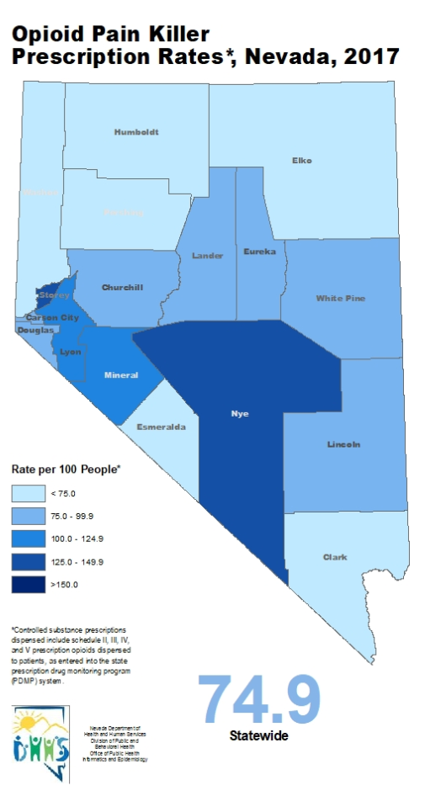
County | Rate
Carson City | 91.1  (90.3-91.8)
Churchill | 98.0  (96.7-99.2)
Clark | 72.2  (72.1-72.3)
Douglas | 91.1  (90.2-91.9)
Elko | 63.3  (62.6-63.9)
Esmeralda | 57.0  (52.3-61.8)
Eureka | 85.6  (81.4-89.7)
Humboldt | 66.7  (65.4-67.9)
Lander | 76.7  (74.5-78.9)
Lincoln | 84.6  (58.5-62.8)
Lyon | 129.9  (129.0-130.9)
Mineral | 158.1  (154.5-161.8)
Nye | 155.6  (154.4-156.7)
Pershing | 69.4  (67.4-71.3)
Storey | 146.9  (143.2-150.6)
Washoe | 87.4  (87.1-87.7)
White Pine | 99.9  (97.9-101.8)
Nevada | 87.4  (87.3-87.6)
(Sources: Office of Public Health Informatics and Epidemiology; PDMP)

Nevada’s benzodiazepine prescribing rate remained stable from 2013 to 2016, then decreased 12% in 2017.

Figure 2. Benzodiazepine Prescriptions Per 100, 2011-2016
US
NV
(Sources: Paulozzi, et al., 2014; Office of Public Health Informatics and Epidemiology; Prescription Monitoring Program)

The benzodiazepine prescribing rate is highest in Nye County (54.3) and Storey County (50.9)—each significantly higher than the state prescribing rate of 33.9. The benzodiazepine prescribing rate decreased in all counties except for Lincoln County as well. Lincoln County increased by 34% from 2016 to 2017, following a 46% increase from 2015 to 2016. The prescribing rate percent change decreased the most in Mineral County (41%), White Pine County (25%), and Esmerelda County (25%) from 2016 to 2017.
The top two opioid prescribing counties—Nye and Storey Counties—are the same counties as the top two Benzodiazepine prescribing counties, indicating these counties are at highest risk for overprescribing.
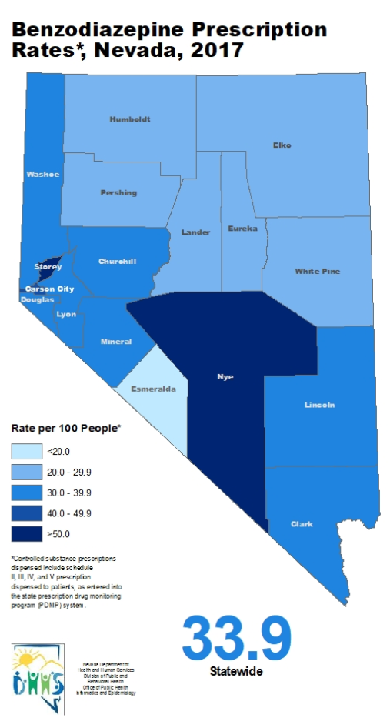
Table 2. Benzodiazepine Prescription Rates Per 100 by County, 2016
County | Rate
Carson City | 42.0  (41.5-42.5)
Churchill | 34.2  (33.4-34.9)
Clark | 33.7  (33.6-33.8)
Douglas | 39.2  (38.7-39.8)
Elko | 24.1  (23.7-24.5)
Esmeralda | 16.8  (14.2-19.4)
Eureka | 26.9  (24.6-29.2)
Humboldt | 24.3  (23.5-25.0)
Lander | 24.0  (22.7-25.2)
Lincoln | 36.9  (35.2-38.6)
Lyon | 37.6  (37.1-38.1)
Mineral | 34.5  (32.8-36.2)
Nye | 54.9  (54.3-55.6)
Pershing | 21.6  (20.6-22.7)
Storey | 53.1  (50.9-55.4)
Washoe | 33.4  (33.2-33.6)
White Pine | 25.8  (24.9-26.8)
Nevada | 34.0  (33.9-34.1)
(Sources: Office of Public Health Informatics and Epidemiology; PDMP)

Opioid-Involved Overdose Deaths
The most recent annual data available for Nevada’s opioid-involved overdose deaths are summarized below. There has been a 21% decrease in overdose-related deaths since 2011.

Figure 3. Opioid-Related Deaths per 100,000, 2011-2017
NV
*Data are preliminary and subject to change.
**Includes ICD-10 codes as underlying cause of death: X40-X44, X60-X64, X85, Y10-Y14, as contributing cause of death: T40.0-T40.4, T40.6
(Sources: CDC Wonder; Office of Public Health Informatics and Epidemiology; Electronic Death Registry System)

The table below shows age-adjusted opioid overdose death rates by county in 2017. Rates are age-adjusted so that they can be compared across regions and with other states and national statistics.

Table 3. Opioid Overdose Death Rates Per 100,000 by County, 2017
County | Number | Age-Adjusted Rate
Carson City | 13 | 20.3  (9.3-31.3)
Churchill | 4 | 15.2  (0.3-30.0)
Clark | 275 | 12.3  (10.8-13.7)
Douglas | 4 | 7.7  (0.2-15.2)
Elko | 3 | 6.6  (0.0-14.0)
Esmeralda | 0 | -
Eureka | 0 | -
Humboldt | 2 | 15.9  (0.0-38.1)
Lander | 0 | -
Lincoln | 0 | -
Lyon | 14 | 27.9  (13.3-42.5)
Mineral | 0 | -
Nye | 8 | 14.7  (13.3-24.9)
Pershing | 1 | 15.7  (0.0-46.6)
Storey | 0 | -
Washoe | 74 | 15.1  (11.7-18.6)
White Pine | 3 | 26.9  (0.0-57.3)
Statewide | 401 | 13.0  (11.8-14.3)
*Data are preliminary and are subject to change.
(Sources: Office of Public Health Informatics and Epidemiology; Electronic Death Registry System)

Age groups affected greatest by opioid deaths were ages 45-54 and ages 55-64, with death rates significantly higher.
Figure 4. Opioid Overdose Death Rates, by Age, 2017
55-64
85+

75-84

65-74

45-54
25-34
35-44
15-24
(Sources: Office of Public Health Informatics and Epidemiology; Electronic Death Registry System)

Opiate-involved overdose deaths were significantly lower among Hispanic and Asian/Pacific Islander residents.
Figure 5. Opioid Overdose Death Rates, by Race/Ethnicity, 2017
American Indian/Alaska Native
Asian/Pacific Islander
Hispanic/Latino
White
Black
(Sources: Office of Public Health Informatics and Epidemiology; Electronic Death Registry System)

Opioid overdose deaths were significantly greater for natural and semi-synthetic (i.e. hydrocodone) opioids for all years displayed. Natural and semi-synthetic deaths are on a decreasing trend since 2012. From 2010-2015, heroin deaths increased, remained stable from 2015-2016, then increased again from 2016-2017. For the last three years, 2015-2017, synthetic opioid deaths (i.e. fentanyl) increased. Methadone overdose deaths decreased from 2010-2017.
Figure 6. Opioid Overdose Deaths by Drug Category, Nevada Residents, 2010-2017
Unspecified Narcotic
Methadone
Synthetic Opioids
Heroin
Natural and
Semi-Synthetic
(Source: Office of Public Health Informatics and Epidemiology)
*Data are preliminary and are subject to change.
**A person can be included in more than one drug group, and therefore the counts above are not mutually exclusive.
From 2012 to 2017, overdose deaths from methamphetamine and heroin increased 260% in Clark County and 433% in Washoe County. Half of the heroin deaths in Clark County and Washoe County included methamphetamine in 2017.
Figure 7. Methamphetamine and Heroin Overdose Deaths, by County, 2012-2017
Washoe County
Clark County
(Sources: Southern Nevada Health District Office of Epidemiology and Disease Surveillance; Washoe County Regional Medical Examiner’s Office)
Heroin overdose deaths were highest among individuals 30-49 years (42%) in Clark County, compared to Washoe County heroin overdose deaths which were highest among individuals 18-29 years (41%) and 50-69 years (38%).
Figure 8. Heroin Overdose Deaths, by Age, 2017
Clark County
Washoe County
(Sources: Southern Nevada Health District Office of Epidemiology and Disease Surveillance; Washoe County Regional Medical Examiner’s Office)
*Cell counts with less than five are suppressed.

Misuse and Related Harms

Adolescent Misuse
The proportion of high school students who self-reported ever using a prescription drug without a doctor’s prescription decreased, though not significantly, from 20.2% to 16.9% from 2011-2015. Prescription drugs were defined as any prescription drugs including, but not limited to: Oxycontin, Percocet, Vicodin, Codeine, Adderall, Ritalin, or Xanax. Due to this broad definition, the question was more of a proxy for prescription opioid use rather than a direct measurement. In 2017, the question was updated to more accurately assess prescription painkiller use. The question now asks if the student has ever used a prescription pain medicine without a doctor’s prescription or differently than prescribed. The lifetime prevalence was 14.8% and use in the past 30 days was 7.0%.

Weighted lifetime prescription drug use was significantly lower among Asian students (5.2%). The same disparity existed for past 30-day prescription drug use, with 2.3% of Asians reporting current use, compared to 7.0% of the state sample.
Figure 9. Lifetime Prescription Painkiller Use, by Race/Ethnicity, 2017
Asian
American Indian/Alaska Native
Black
Native Hawaiian/Pacific Islander
White
Hispanic/Latino
Multi-race
(Source: Lensch et al., 2017)

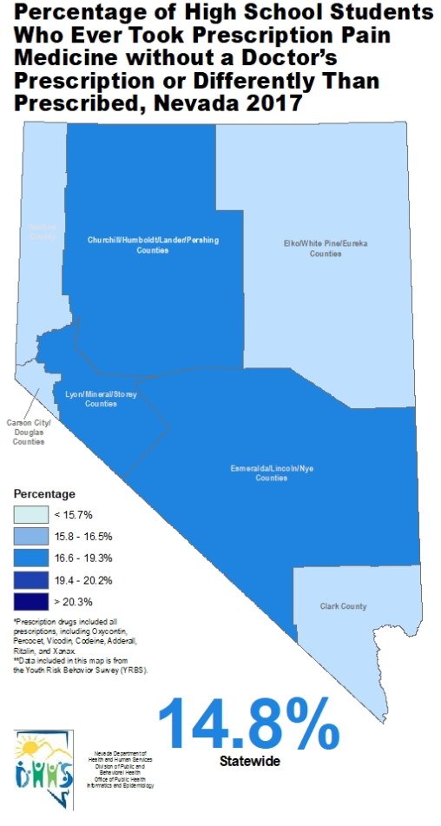
Lifetime use of a painkiller without a prescription did not vary significantly from county to county. The source of the high school data aggregates some counties together so it is not known if the county groupings increased or decreased the total percentage.

County | Percentage
Carson City/Douglas | 15.5%  (8.1-22.9)
Churchill/Humboldt/  Lander/Pershing | 18.1%  (13.7-22.6)
Clark | 14.5%  (12.5-16.5)
Elko/White Pine/  Eureka | 14.2%  (9.9-18.4)
Lincoln/Nye | 12.5%  (7.6-16.9)
Lyon/Mineral/Storey | 18.7%  (12.4-25.1)
Washoe | 14.8%  (11.8-17.9)
Statewide | 14.8%  (13.2-16.4)
Table 4. Percentage of High School Students Who Ever Took Prescription Pain Medicine without a Doctor’s Prescription or Differently Than Prescribed, 2017

(Source: YRBS)

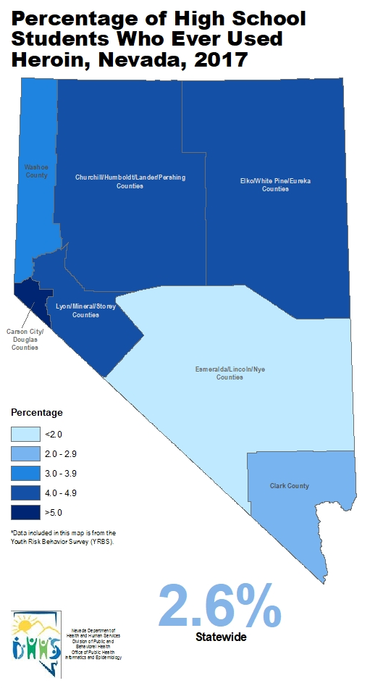
Self-reported lifetime heroin use in high school did not change significantly from 2013 to 2017. Lifetime heroin use did not differ significantly by county. Prevalence was significantly lower among Native Hawaiian/Pacific Islander respondents. Again, the high school data contains aggregated counties which may affect rankings.
Table 5. Percentage of High School Students Who Ever Used Heroin, 2017
Counties | Percentage
Carson City/Douglas | 5.1%  (0.0-10.7)
Churchill/Humboldt/  Lander/Pershing | 4.3%  (2.4-6.3)
Clark | 2.1%  (1.2-3.1)
Elko/White Pine/ Eureka | 4.1%  (1.4-6.8)
Lincoln/Nye | 1.9%  (0.5-3.3)
Lyon/Mineral/Storey | 4.6%  (1.0-8.2)
Washoe | 3.2%  (2.1-4.3)
Statewide | 2.6%  (1.8-3.3)
(Source: YRBS)

Adult Misuse
According to the National Survey on Drug Use and Health (NSDUH), Nevada ranks fourth for the percentage of people aged 12 or older who used prescription pain relievers nonmedically in the past year from 2012-2014 (5.20%), down from second from 2010-2012 (5.92%) (Lipari et al., 2017).
The Behavior Risk Factor Surveillance System instead assesses past 30-day use of a painkiller to get high, where 0.7% of adults in Nevada indicated yes, in aggregated data from 2013-2016.
Table 6. Past Month Percentage Who Used a Painkiller to Get High, by County, 2013-2016
County | Percentage
Carson City | 0.7%
Churchill | 0.1%
Clark | 0.6%
Douglas | 1.2%
Elko | 0.7%
Esmeralda | 0.0%
Eureka | 0.0%
Humboldt | 0.0%
Lander | 0.0%
Lincoln | 0.0%
Lyon | 1.5%
Mineral | 1.2%
Nye | 0.5%
Pershing | 0.0%
Storey | 0.3%
Washoe | 1.0%
White Pine | 0.0%
Statewide | 0.7%
(Source: Behavioral Risk Factor Surveillance System)

Past year heroin use in Nevada among those aged 12 or older was the same as the national average of 0.33% in 2014-2015 (SAMHSA, 2017).

Prenatal Substance Misuse
Self-reported use of heroin and other opioids has been on an increasing trend since 2011. Because substance use during pregnancy is self-reported by mothers, reported rates are likely lower than actual rates due to underreporting, and expectant mothers may be reluctant to be fore forthcoming on the birth record for a variety of reasons.
Figure 10. Self-Report Prenatal Substance Misuse Rates, 2010-2017
Opioids excluding Heroin
Heroin
(Source: Nevada Electronic Birth Registry System)
*Rates per 1,000 live births
Self-reported heroin use and opiate use while pregnant by county is listed in Table 7.
Table 7. Rate of Self-Reported Opiate Use While Pregnant, 2012-2016
County | Heroin | Opiates
Carson City/Douglas | 2.0 | 0.7
Churchill/Humboldt/Lander/Pershing | 0.3 | 0.8
Clark | 0.7 | 1.7
Elko/Eureka/White Pine | 0.3 | 2.4
Esmeralda/Lincoln/Nye | 5.2 | 2.1
Lyon/Mineral/Storey | 1.9 | 1.3
Washoe | 1.0 | 1.1
Statewide | 0.8 | 1.6
*Rates are per 1,000 live births
**Data are preliminary and subject to change.

From April 2017 to March 2018, 871 pregnant women on Medicaid were diagnosed with an opioid use disorder. Of these women, only 112 were on medication-assisted treatment and 19 submitted substance use treatment claim.
Figure 11. Number of Pregnant Women Receiving Treatment, Medicaid, April 2017-March 2018
Medication-Assisted Treatment
Opioid/Substance Use Treatment
(Source: DHHS Office of Analytics; Division of Health Care Financing and Policy)
*Opioid use disorder defined with diagnosis code F11.x.
**Buprenorphine and Methadone were identified with a set of 399 NCD codes.
The rate of neonatal abstinence syndrome increased from 2012 to 2016, then decreased 15% in 2017.
Figure 12. Neonatal Abstinence Syndrome, 2010-2017

(Source: Hospital Inpatient Department Billing and Nevada Electronic Birth Registry System)
*ICD-10 codes replaced ICD-9 codes in last quarter of 2015, therefore data prior to that may not be directly comparable.

Medical Interventions
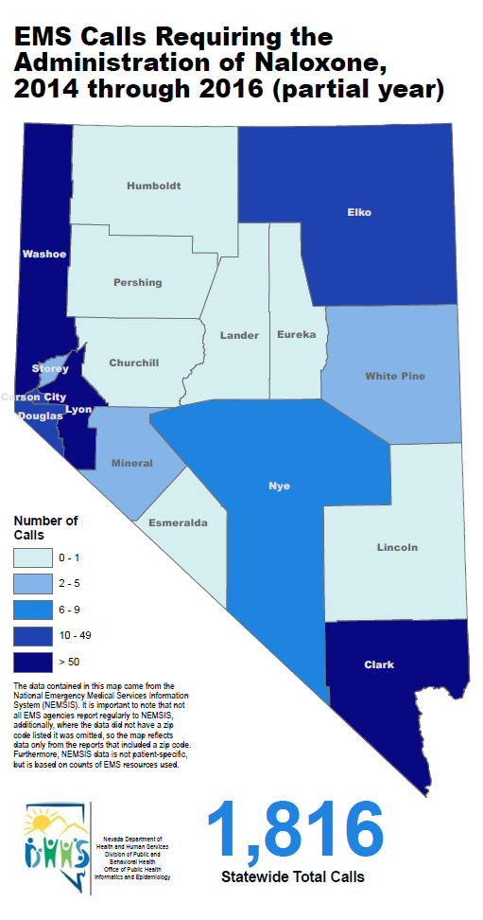
The rate of EMS calls requiring administration of naloxone is higher for Lyon County. Of the seven counties listed in the 0-1 calls category, five counties had zero EMS calls requiring naloxone administration: Esmeralda, Humboldt, Lander, Lincoln, and Pershing. Lincoln County EMS was part of the NROOR funding and had naloxone on the ambulances. It is unknown if naloxone is carried by EMS in the other counties with no administration.

Table 7. Rate of EMS Calls Requiring Naloxone by County, 2014-2016
County | Number | Crude Rate
Carson City | 49 | 30.1  (21.7 - 38.5)
Churchill | 1 | 1.3  (0.0 - 3.9)
Clark | 1,089 | 17.3  (16.3 - 18.4)
Douglas | 14 | 9.6  (4.6 - 14.6)
Elko | 47 | 29.6  (21.1 - 38.0)
Esmeralda | 0 | 0.0
Eureka | 1 | 17.3  (0.0 - 51.1)
Humboldt | 0 | 0.0
Lander | 0 | 0.0
Lincoln | 0 | 0.0
Lyon | 86 | 53.1  (41.8 - 64.3)
Mineral | 3 | 21.7  (0.0 - 46.2)
Nye | 6 | 4.4  (0.9 - 8.0)
Pershing | 0 | 0.0
Storey | 3 | 24.7  (0.0 - 52.7)
Washoe | 513 | 38.7  (35.4 - 42.1)
White Pine | 4 | 13.2  (0.3 - 26.1)

(Source: NEMSIS)
Naloxone administration in emergency departments increased from 2013-2016. Naloxone was only used for a small percentage of total opioid poisonings (15.2%) and opioid encounters (3.8%).
Figure 13. Emergency Department Naloxone Administrations, 2010-2016
Opioid Encounters
Opioid Poisonings
(Source: OPHIE, Emergency Department Billing Data)
*Includes ICD-9 Codes of 965.0, 304.0, 304.7, 305.5, E850.0, E850.1, E850.2 and ICD-10 Codes of T40.0-T40.4, and T40.6, F11, and J23.10.
**Opioid poisonings are a subset of opioid encounters.
Both ED and IP admissions for opiates increased from 2010-2016. Opioid poisonings, a subset of opioid-related admissions, remained steady during those same years among ED and IP admissions. In 2014, the highest rate of opioid-related IP stays was among individuals aged 45-64 years, while opioid-related ED visits were highest among individuals 25-44 years old. ED visits were highest in this age group in all 30 states for which ED data were available. There was variation among highest age group for IP admissions, with rates highest among individuals 45-64 years in only nine states. Females had a higher rate of IP stays, while men had a higher rate of ED visits (Weiss et al., 2017).
Figure 14. Opiate-Related Hospital Admissions, 2010-2016
Opioid Poisonings IP
Opioid Poisonings ED
Opioid-Related IP
Opioid-Related ED
(Source: Center for Health Information Analysis, Hospital Inpatient and Emergency Department Billing Data)
*A person can be included in more than one drug group, therefore the counts above are not mutually exclusive.
**In October 2015, ICD-10-CM codes were implemented. Previous to October 2015, ICD-9-CM codes were used for medical billing. Therefore, 2015 data consists of two distinct coding schemes, ICD-9-CM and ICD-10-CM respectively. Due to this change in coding schemes, hospital billing data from October 2015 forward may not be directly comparable to previous data.
While Figure 14 shows the number of opioid poisonings has remained stable, Figure 15 displays that the type of opioid drug causing opioid poisonings has changed. Opioid poisonings from heroin have increased in the ED and IP. Methadone and other opioid and narcotics have increased in ED encounters, while decreasing in IP admissions.
Figure 15. Opioid-Related Poisoning Hospital Admissions by Drug Category, 2010-2017
Other Opioids and Narcotics
Heroin
Methadone
Opioid Poisonings Emergency Department
Opioid Poisonings Inpatient Admissions
*A person can be included in more than one drug group, and therefore counts are not mutually exclusive. In 2016, the use of E-codes was eliminated and counts are now mutually exclusive.

State of Current Services and Funding

Availability of Medication-Assisted Treatment
There are 15 Opioid Treatment Programs (OTPs) in Nevada across Clark County, Washoe County, and Carson City (see Table 10). Only one OTP location, Life Change Center Sparks, is at capacity. To address this, they are planning to open another facility in Reno. The two Mission Treatment Center locations and the four Center for Behavioral Health locations said they would add more staff as client levels increased, stating that there was no limit to their capacity. One OTP does not provide maintenance therapy, as it is only using MAT to detox and then refer the client to another provider. The 14 rural counties in Nevada have no OTPs. Capacity to provide MAT services among the 12 clinics responding to inquiry is 4,693 clients. No information was available on the remaining three facilities.
Three OTPs, Adelson Clinic in Clark County and Life Change Center (one location in Washoe County and one in Carson City), receive funding from SAPTA through the Federal Block Grant. At those facilities, the majority of clientele seeking MAT are publicly funded. Requests for number served who are publicly funded or privately funded were not returned by 12 OTPs, but most clients should be privately funded at those facilities. See Table 9 for more information on county served, program capacity, and psychosocial interventions offered.

Table 9. Nevada Opioid Treatment Program Location, Capacity, and Services
Program | County | Program Capacity | Current Number Served | Number served -publicly funded |  | Number served - privately funded | Psychosocial interventions offered
Adelson Clinic | Clark | 300 | 183 | Medicaid  69 | SAPTA  75 | 21 | Counseling and refer/coordination of care for other services needed by clients
Center for Behavioral Health
- Center for Behavioral Health – Cheyenne | Clark | 200 | 200 | -- |  | -- | Counseling (variety of groups, including gender specific), family counseling, case management, coordinate care when mental health services are needed, physician available everyday
- Center for Behavioral Health – Desert Inn | Clark | 450 | 450 | -- |  | -- | Counseling (variety of groups, including gender-specific), family counseling, case management, coordinate care when mental health services are needed, physician available everyday
- Center for Behavioral Health – McDaniel | Clark | 400 | 400 | -- |  | -- | Counseling (variety of groups, including gender-specific), family counseling, case management, coordinate care when mental health services are needed, physician available everyday
- Center for Behavioral Health – Reno | Washoe | 300 | 300 | -- |  | -- | Counseling (variety of groups, including gender-specific), Family Counseling, case management, coordinate care when mental health services are needed, Physician available 2 days per week
Desert Treatment Clinic | Clark | -- | -- | -- |  | -- | --
Eastern Treatment Clinic | Clark | -- | -- | -- |  | -- | --
Mission Treatment Centers
- Mission Treatment Centers Henderson | Clark | 258 | 258 | -- |  | -- | Counseling, coordinate care with other agencies for the client’s needs (medical, mental health)
- Mission Treatment Centers Las Vegas | Clark | 260 | 260 | -- |  | -- | Counseling, coordinate care with other agencies for the client’s needs (Medical, Mental Health)
Nevada Treatment Center (Nevada Integrated Behavioral Services Inc.) | Clark | 300 | 125 | -- |  | -- | Counseling (L1, 2.1 and 2.5), case management, COD services, coordination of care for client’s needs.
New Beginnings Counseling Center Eastern | Clark | 800 | 490 | -- |  | -- | Counseling, domestic violence, DUI class and the victim impact panel
New Beginnings Counseling Center Lake Mead | Clark | 500 | 180 | -- |  | -- | Counseling, domestic violence, DUI class and the victim impact panel
Life Change Center |  |  |  | Medicaid  435 | SAPTA  107 | 241
- Life Change Center – Carson City | Carson | 275 | 275 |  |  |  | Counseling; case management by dedicated CM staff; family programming: for women: parenting and prevention program, co-occurring capable program so can screen and then assist with referral and coordination of care; medication management; assessment for initial clients for proper placement; gardening program; social recreation program
- Life Change Center – Sparks | Washoe | 450 | 450 |  |  |  | Counseling; case management by dedicated CM staff; family programming: for women: parenting and prevention program, co-occurring capable program so can screen and then assist with referral and coordination of care; medication management; assessment for initial clients for proper placement; gardening program; social recreation program
Seven Hills Hospital, Inc. | Clark | -- | -- | -- |  | -- | None

In August 2017, all 192 Data 2000 waivered providers were emailed a brief survey inquiring about their buprenorphine prescribing limit, current caseload of MAT patients, reasons for not prescribing at capacity, resources that could increase their MAT prescribing, counties prescribing in, use of opioid and naloxone co-prescribing, psychosocial interventions offered and interventions provided through contract arrangements. Ten email addresses were “undeliverable,” reducing the sample to 182. The survey received 84 responses, with eight indicating they did not want to participate and five not completing the survey, leaving 71 responses for analysis. Survey results presented below should be interpreted with caution, as only 39% of Data 2000 waivered providers completed the survey.
OBOTs prescribe in 10 counties: Carson City (5), Churchill (2), Clark (147), Elko (3), Humboldt (1), Lincoln (1), Lyon (1), Nye (1), Pershing (2), and Washoe (30). Of the OBOTs who responded to our electronic survey, none were prescribing at their capacity, although one had just increased their limit so they were prescribing to their prior capacity. Three-quarters (75%) of respondents work in private practice. Nearly all (97%) of respondents said their practice/agency was accepting new clients. The number of patients the providers were certified to prescribe to ranged, with 47% 30 patient certified, 30% 100 patient certified, and 23% 275 patient certified. While less than half (47%) of providers were certified to prescribe to only 30 patients, 74% of respondents were prescribing in this range. Almost one-third (30%) were allowed to prescribe buprenorphine to up to 100 patients, but only 18% of respondents actually were. Finally, while nearly one-quarter (23%) had increased their prescribing limit to 275 patients, 8% were utilizing this ability (see Figure 16).

Figure 16. Comparison of Provider Capacity and Actual Prescribing

Respondents were asked to select all of the reasons that they were not prescribing at their Buprenorphine capacity and given the opportunity to write in other reasons that were not listed. As shown in Figure 17, the most often cited reasons for not prescribing at capacity were no time for reimbursement rates insufficient, additional patients, and not being referred more patients.

Figure 17. Reasons for Not Prescribing at Capacity

*represents aggregated responses written into Other
**Question was a select all that apply so the number of answers is more than the number of respondents
As a follow-up, participants were then asked what resources would increase their willingness to prescribe to capacity. The most common response was that the prescriber would like “being provided with information about counseling resources for patients in my local area,” followed by that “nothing would increase my willingness to prescribe to capacity.”
Figure 18. Resources that Would Increase Providers’ Willingness to Prescribe at Capacity

*represents aggregated responses written into “Other”
**Question was a select all that apply so the number of answers is more than the number of respondents.

Over half (52%) of survey respondents indicated that they co-prescribed naloxone with opioid painkillers for high-risk patients, with 11% of those citing doing so “frequently” and 3% “always.”

Figure 19. Frequency of Opioid Painkiller and Naloxone Co-prescribing
52% engage in
co-prescribing
The majority of survey respondents (69%) were employed in a practice that offered psychosocial services or interventions and 48% provided psychosocial interventions through contract arrangements with qualified behavioral health providers. The most common service offered was buprenorphine induction and maintenance. Counseling and Substance Use Disorder Evaluation were also common responses.
Figure 20. Types of Psychosocial Services/Interventions Offered by Provider Practices

Socio-Political Environment
Policy/legislation passed in Nevada related to the opioid overdose crisis supportive of MAT is summarized below.
The Good Samaritan Drug Overdose Act of 2015 (SB 459) provides for immunity from prosecution for personal use and possession of controlled substances from individuals seeking medical attention for themselves or others during a drug overdose. Immunity does not extend to large quantities for sale or trafficking.
SB 459 requires that prescribing physicians obtain a patient utilization report on the Prescription Monitoring Program before the initiation of a schedule II, III, or IV prescription drug for a new patient, or for a course of treatment lasting longer than seven days that is part of a new course of treatment for an existing patient. SB 459 also requires the pharmacists to update the system within the next business day of filling a prescription. Participation in the PMP has increased from 16% to 98% since the legislation passed.
With the passage of SB 459, a physician can prescribe an opioid antagonist (i.e. naloxone) directly or by standing order to a person who is at risk of overdose or to a family member, friend, or other person in a position to assist a person who is at risk of experiencing an overdose. Additionally, SB 459 allows a pharmacist to dispense an opioid antagonist without a prescription. Finally, an unlicensed person may store and/or dispense an opioid antagonist under a standing order from a properly authorized prescriber, as long as the medication is dispensed without charge or compensation.
In 2016, Nevada Gov. Sandoval established a Drug Abuse Prevention Task Force led by First Lady Kathleen Sandoval. The governor convened and chaired a statewide drug summit in the summer of 2016. The summit assembled over 500 stakeholders, including legislators, healthcare professionals, law enforcement, judges, and individuals in recovery from a substance use disorder. Based on their recommendations, Gov. Sandoval announced in his 2017 State of the State Address that he was introducing the Controlled Substance Abuse Prevention Act, which will provide more training and reporting, and heightened protocols for healthcare professionals with prescribing controlled substances. Additionally, the Nevada Attorney General chairs a Substance Abuse Working Group consisting of nine members. The Working Group submitted recommendations for combating the opioid crisis to the Nevada Legislature. The Office of the Attorney General proposed SB 59, utilizing the recommendations of the Working Group. SB 59 requires reporting of controlled-substance violations, prescription drug-related overdoses or deaths, and stolen prescription drugs to the PMP. The bill went into effect on July 1, 2017.
The Controlled Substances Abuse Prevention Act (AB 474), which went into effect on Jan. 1, 2018, requires doctors and hospitals to report any drug overdoses to the state. Additionally, licensing boards can access PMP data to investigate inappropriate prescribing, dispensing, or use of a controlled substance. Prescribers will now need to perform a risk assessment before prescribing a controlled substance. For prescriptions over 30 days in length, a prescription medical agreement with the patient must be created. The prescriber must also complete a risk of abuse assessment and obtain a patient utilization report every 90 days for the duration of the prescription. Numerous trainings have been held and materials distributed to educate healthcare providers on AB 474.
Any physician or physician’s assistant who is registered to prescribe controlled substances must complete at least two hours of training specifically addressing the prescribing of opioids or addiction every licensing period.
There is no dedicated state funding for MAT. All funding is allocated from the Block Grant. Dedicated state funding does not exist for naloxone either. The Commission on Behavioral Health has approved new criteria so programs will no longer be able to deny clients residential treatment who are stabilized on MAT. The new criteria went into effect April 1, 2018.
All opioid dependence and overdose reversal medications are covered by three managed care organizations (MCOs)—Amerigroup, Health Plan of Nevada, and Silver Summit Health Plan—but prior authorization and quantity limits differ. Table 10 displays prior authorization and quantity limits required by each plan.

Table 10. Health Care Plan Prior Authorization and Quantity Limits by Medication
Medication | Amerigroup |  | Health Plan of Nevada |  | Silver Summit Health Plan |  | Fee for Service
 | PA | Quantity Limits | PA | Quantity Limits | PA | Quantity Limits | PA | Quantity Limits
Overdose Medications
Narcan (naloxone)
Narcan Nasal Spray (naloxone)
Evzio (naloxone)
Opioid Dependence Medications
Vivitrol (naltrexone)
ReVia (naltrexone)
Suboxone (buprenorphine/ naloxone [bup/nal])
Zubsolv (bup/nal)
Bunavil (bup/nal)
Subutex (buprenorphine)
Detoxification/Withdrawal Medications
Dolphine (methadone)
Methadose (methadone)
(Announcement 0921, 2017)
**Prior Authorization (PA)

Naloxone Prevention Initiatives
When this needs assessment was first conducted in July 2017, naloxone distribution was limited to pharmacies and a few hospitals. Naloxone is available without a prescription through standing orders at Walgreens and CVS Pharmacies and Smith’s Food and Drug Stores. Naloxone is distributed at five (5) Nevada Rural Opioid Overdose Reversal Program (NROOR) funded hospitals in Lincoln, Lyon, Mineral, Nye, and White Pine counties to patients discharging from the hospital following an overdose.
Overdose education and naloxone distribution (OEND) expanded in 2018 through Opioid STR funding and activities. Overdose education includes training on how to recognize an overdose, the Good Samaritan law, and how to administer naloxone. Community-based organizations (CBO) can apply to serve as naloxone distribution sites. Eligible CBO types include:
- Needle exchange programs,
- SAPTA-certified or Medicaid eligible providers providing treatment services,
- Federally Qualified Health Centers (FQHC),
- Jails,
- Peer recovery communities,
- Health districts,
- Other STR funded treatment and recovery support entities.
*Exemptions to this criteria may be applied in rural and frontier high need areas or in cases of Public Health Emergency.
To extend naloxone availability, upon request from partnering community coalitions, the Opioid STR grant will hold educational events to offer OEND to their constituents. A statewide tour of community coalitions began in June 2018, training and distributing naloxone 773 individuals.
Beginning in April 2017, Trac-B Exchange in Las Vegas opened the state’s first permanent needle exchange, which also now delivers OEND free of charge. In Northern Nevada, Change Point Harm Reduction Center, provides OEND, along with syringe services and rapid HIV and hepatitis C testing. The three Integrated Opioid Treatment and Recovery Centers (IOTRC) are offering OEND to clients that are at risk of overdose, client family members, transitional living facilities, homeless shelters, community-based organizations, and weekly motels. IOTRCs have distributed 852 kids and reported 15 reversals through March – October 2018. Southern Nevada Health District is a SAMHSA First Responders – Comprehensive Addiction and Recovery Act grantee, delivering OEND services throughout Clark County. Southern Nevada Health District provided OEND to 2,798 individuals through March – October.
NROOR has trained 117 EMTs on overdose education and naloxone administration. Although not specifically education on naloxone, 46 healthcare providers, 37 mental health professionals, drug court professionals, and attendees of a community college library committee event received training on overdose education. Presentations on integrating naloxone and overdose prevention into clinical practice were given at the annual meeting of the Nevada Academy of Family Physicians and at the annual Orvis Nursing School healthcare symposium. The Nevada Rural Preparedness Summit provided a presentation on expanding naloxone access. The Carson City Law Enforcement Summit and the Las Vegas Opioid Crisis Summit included naloxone training. One coalition, covering the three rural counties of Humboldt, Pershing, and Lander counties, is training first responders on naloxone (Stein-Seroussi, Grabarek, & Hanley, 2016).

Prevention Efforts
A description of Nevada’s current prevention efforts, which are primarily completed SAMHSA Strategic Prevention Framework – Partnership for Success-funded community coalitions, are summarized below.
Social marketing/media campaigns are a strategy being implemented by 11 community coalitions, including nearly 10,000 paid ads and 14,000 public service announcements (Stein-Seroussi et al., 2016). Coalitions had a media presence with the release of ‘Women of Childbearing Years,’ an opioid prevention TV ad; and students from Pershing County High School produced prescription drug abuse ads. An associated website was also created (www.healthiernv.org) to provide information to prescribers, families and policymakers.
Eight (8) community coalitions coordinate semi-annual Take Back events and utilize drop boxes in law enforcement facilities in between Take Back events (Stein-Seroussi et al., 2016). Funded by the Federal Office of Rural Health Policy, NROOR is providing naloxone to EMTs and paramedics and training them on its use in seven counties: Esmeralda, Eureka, Lincoln, Lyon, Mineral, Nye and White Pine.
Eleven coalitions have reported coordinating continuing education opportunities for physicians (Stein-Seroussi, Grabarek, & Hanley, 2016). Additionally, presentations to educate parents, youth, seniors, real estate agents, and veterans are conducted statewide to help them understand issues.
Over the past year, four new websites have been created. Three Nevada websites target educating the public and providers on the opioids. Prescribe365, run by the State of Nevada Division of Public and Behavioral Health is a hub of information for patients and providers. Healthcare provider information includes educational materials surrounding AB 474 and naloxone co-prescribing. Consumer materials for patients, friends and family contain information on how to use naloxone and links to treatment locators. Know your Pain Meds is operated by the Nevada State Board of Examiners, Nevada State Board of Pharmacy, and Nevada State Board of Nursing. The website contains information on the PMP, naloxone, alternatives to opioids for managing pain, and filing a concern about a medical provider. The Nevada STR website has information on funding opportunities, training opportunities, naloxone education and SBIRT materials, and STR publications. The fourth website is designed to make local data available to the public. The Nevada Opioid Overdose Surveillance Dashboard contains death rates, opioid-related emergency department visits and inpatient admissions, and opioid prescriptions at the county- and zip-code level.

Recovery Support Initiatives
At this time, Nevada has one peer-run recovery community organization, Foundations for Recovery, which is in Las Vegas. Foundations for Recovery offers a peer-recovery community center; peer recovery coaching; mutual aid support groups; life skills classes; high school equivalency (HSE) tutoring and testing; parenting classes; mental health first aid; suicide prevention trainings; houses the Southern Nevada NAMI affiliate and hosts the annual Rally for Recovery. All services are available to the public, including women with children, and pregnant women. Foundations for Recovery staff was trained in Medication Assisted Recovery Services (MARS), which is a peer-initiated and peer-based recovery support project sponsored by the National Alliance of Medication-Assisted (NAMA) Recovery.
The state of Nevada, through the Nevada Behavioral Health Association, offers a voluntary certification process for peer-support specialists. In-person and online training opportunities are available for individuals seeking peer-support specialist training.
In 2015, Nevada was one of 24 states to be awarded a Certified Community Behavioral Health Clinic (CCBHC) demonstration grant through SAMSHA, under the Excellence in Mental Health Act. In 2016, the state became one of eight selected to carry out the formal implementation of CCBHCs. Phase 1 of the project offered states one-year planning grants to develop their CCBHC program and Phase 2 enabled the selected states to move forward with the development of CCBHCs. Nevada has two CCBHCs located throughout the state (currently in rural areas) that provide a comprehensive range of mental health and substance use disorder services, particularly to vulnerable individuals with complex needs. 7 more agencies have been selected to build CCBHC services moving forward to further address coverage across the state. Peer support and family support services are included in the array of services CCBHCs are required to offer and provide.
No efforts targeting clients related to re-integration following incarceration existed when this needs assessment was completed in July 2017. Opioid STR funds are now beginning to be used to address this. Case managers have been placed strategically for screening and referral of pre-arrest individuals, warm handoff from detention centers to treatment facilities, and in post-release care following prison. Assessment of how these positions are reducing recidivism and impacting other outcomes is occurring and conversations of where other sustainable programming can be implemented is occurring.

Other Opioid Funding Sources
All other funding to address the opioid crisis is described in Table 11.
Table 11. Nevada Funding to Address the Opioid Crisis
Funding Stream | Strategies/Activities | Funding  Period
CDC Prevention for States (PFS) | - Expand and improve proactive reporting  - Conduct public health surveillance with PMP data and disseminate quarterly reports  - Identify and provide technical assistance to high-burden communities and counties to address problematic prescribing  - Create an opioid data dashboard  - Link deaths, hospitalizations, and prescriptions of individuals  - Create mapping of funded activities to find gaps  - Administer CDC’s statewide media campaign  - Link health data sets and law enforcement data sets | 8/16-7/19
CDC Enhanced State Surveillance of Opioid-Involved Morbidity and Mortality (ESOOS) | - Increase timeliness of aggregate nonfatal opioid overdose reporting  - Increase the timeliness of fatal opioid overdose and associated risk factor reporting  - Disseminate surveillance findings to key stakeholders working to prevent or respond to opioid overdoses | 9/17-8/19
CDC Opioid Overdose Crisis | - PDMP and HealthHIE Nevada Integration  - Development of a BadBatch notification system  - Implementation of OpenBeds | 9/18-8/19
SAMHSA Strategic Framework Partnership for Success (PFS) | - Reduce the nonmedical use of prescription drugs among persons 12 and older and the consequences that result from such use, with a focus on persons ages 12-25  - Implement a comprehensive prevention strategy through community education, social marketing/media, physician training, and drop boxes/Take Back events through 13 funded coalitions | 9/13-9/18
SAPG Block Grant: Funding Opportunity 003 | - Target efforts to encourage the use of Prescription Drug Monitoring System by prescribers  - Provide education on the use of naloxone and education on the Good Samaritan Law | 4/17-9/19
Nevada Rural Opioid Overdose Reversal Program (NROOR) | - Provide naloxone administration training to EMS personnel  - Provide initial stock of naloxone to EMS services that did not have it in their formulary  - Provide patient education, substance abuse treatment referrals, and intranasal naloxone to opioid overdose patients upon discharge | 9/15-8/17
FQHC Incubator Project | - Implement system design models that will most rapidly address the gaps in their systems of care  - Deliver evidence-based treatment interventions including medication and psychosocial interventions  - Report progress toward increasing availability of treatment for OUD and reducing opioid-related overdose deaths based upon measures developed in collaboration with the Department of Health and Human Services  - Improve retention in care, using a chronic care model | Upon Receipt – 4/18
Harold Rogers Prescription Drug Monitoring Program Grant (Reno Police Department) | - Analyze PDMP data in order to identify high-risk populations, geographic hotspots, and the relationship between heroin arrests and opioid prescriptions | 10/15-9/18
Attorney General Volkswagen Settlement Money | - Design and implement a program that promotes awareness and understanding of the dangers and consequences of prescription drug misuse  - Connect those at risk of developing prescription drug dependency or abuse to preventive services  - Provide education on the dangers of prescription misuse, neonatal exposure, youth accidental overdose  - Provide resources for chronic pain management and preventive service programs to avert prescription drug misuse and dependency  - Provide the locations of where unused prescription drugs can be taken for disposal and destruction  - Promote awareness of proper storage of prescription drugs  - Distribute naloxone to law enforcement | 10/17-6/19
First Responders – Comprehensive Addiction and Recovery Act Cooperative Agreement (Southern Nevada Health District) | - Train individuals on using naloxone in a suspected overdose  - Establish referral protocols  - Join advisory council  - Educate on Good Samaritan Law | 10/17-10/21

Gaps in Services and Policies
Only three of Nevada’s 17 counties are considered urban (Clark, Washoe, and Carson City), accounting for 91% of the state’s population. The remaining counties are considered rural or frontier (meaning less than 1 person per 7 square miles). The average distance between acute care hospitals in rural Nevada and the next level of care or tertiary care hospital is 114.7 miles and the average distance to the nearest incorporated town is 46.5 miles (Griswold et al., 2017).
Nevada’s rurality presents issues with access to care in all types of medical and behavioral health. MAT services are limited in rural areas, with OTPs only existing in the three urban counties. Access to OBOTs is better, with access in 10 counties: Washoe, Clark, Carson, Churchill, Elko, Humboldt, Lyon, Lincoln, Pershing, and Nye. There is still a gap in MAT when considering Mineral and Storey counties lack access to an OBOT and are counties with some of the highest percentages of individuals in treatment for opiates.
There is a gap in the availability of naloxone among individuals who are legally prescribed painkillers by their doctor, with the co-prescribing of naloxone and opioids currently being underutilized by healthcare providers. With naloxone distribution following hospitalization for an overdose only available at five rural hospitals in Mineral, Nye, Lyon, and Lincoln counties, patients in the remaining counties are still at greater risk of overdose leaving the hospital. IOTRC Mobile Recovery Outreach Team services have begun in emergency rooms, reducing this gap in some hospitals and efforts are underway to expand to more hospitals. Some towns do not have any of the three pharmacies with standing orders for naloxone and naloxone distribution events thus far have been held on only one occasion in many rural towns.
Recovery supports are limited in many regions to 12-step meetings and in some frontier communities such meetings are rare or non-existent.
With coordinated care management, not currently reimbursable by Medicaid, the connections between varying levels of care and necessary supports is lacking.

Resources
Centers for Disease Control and Prevention (CDC). (2018, July 31). U.S. State Prescribing Rates, 2017. Retrieved from https://www.cdc.gov/drugoverdose/maps/rxstate2017.html
CDC. (2017, August 30). Understanding the Epidemic. Retrieved from https://www.cdc.gov/drugoverdose/epidemic/index.html
Griswold, T., Packham, J., Gunawan, A., Etchegoyhen, L., Jorgensen, T., & Marchand, C. (2017, January). Nevada Rural and Frontier Health Data Book – Eighth Edition. University of Nevada Reno School of Medicine Office of Statewide Initiatives.
Guy, G. P., Zhang, K., Bohm, M. K., Losby, J., Lewis, B., Young, R., . . . Dowell, D. (2017, July 7). Vital Signs: Changes in opioid prescribing in the United States, 2006-2015. MMWR Morbidity and Mortality Weekly Report, 66(26), 697-704.
Hartley, S. WCSD School Counseling & Drug Free Schools. 2011 Washoe County School District Youth Risk Behavior Survey Results.
Levi, J., Segal, L. M., & Fuchs Miller, A. (2013, October). Prescription Drug Abuse: Strategies to Stop the Epidemic 2013. Retrieved from http://healthyamericans.org/assets/files/TFAH2013RxDrugAbuseRpt16.pdf
Lensch, T., Baxa, A., Zang, F., Gay, C., Larson, S., Clements-Nolle, K., Yang, W. State of Nevada, Division of Public and Behavioral Health and University of Nevada, Reno. 2015 Nevada High School Youth Risk and Behavior Survey (YRBS).
Lensch, T., Martin, H., Zang, F., Parrish, B., Clements-Nolle, K., Yang, W. State of Nevada, Division of Public and Behavioral Health and University of Nevada, Reno. 2017 Nevada High School Youth Risk and Behavior Survey (YRBS).
Lipari, R. N., Van Horn, S. L., Hughes, A., & Williams, M. (2017, July 13). State and substate estimates of nonmedical use of prescription pain relievers. Retrieved from https://www.samhsa.gov/data/sites/default/files/report_3187/ShortReport-3187.html
National Safety Council. (2018). Prescription Nation 2018: Facing America’s opioid epidemic. Retrieved from http://healthyamericans.org/health-issues/wp-content/uploads/2018/04/Prescription-Nation-2018.pdf
Nevada High Intensity Drug Trafficking Areas. (2016, June). 2016 Nevada HIDTA Threat Assessment.
Nevada High Intensity Drug Trafficking Areas. (2018, June). 2018 Nevada HIDTA Threat Assessment.
Office of Epidemiology and Disease Surveillance. Southern Nevada Health District. Mortality from Drug Poisoning/Overdose in Clark County, 2012-2017. Las Vegas, November 2018.
Office of Public Health Informatics and Epidemiology. Division of Public and Behavioral Health. 2013 Nevada Youth Risk Behavior Survey. Carson City, Nevada. February 2014.
Paulozzi, L., J., Mack, K. A., & Hockenberry, J. M. (2014, July 4). Vital Signs: Variations among states in prescribing of opioid pain relievers and benzodiazepines – United States, 2012. Retrieved from https://www.cdc.gov/mmwr/preview/mmwrhtml/mm6326a2.htm
Seth, P., Scholl, L., Rudd, R. A., & Bacon, S. (2018, March 30). Overdose Deaths Involving Opioids, Cocaine, and Psychostimulants – United States, 2015-2016. MMWR Morbidity and Mortality Weekly Report, 67(12), 348-358.
Scholl, L., Seth, P., Kariisa, M., Wilson, N., & Baldwin, G. (2018, December 21). Drug and Opioid-Involved Deaths – United States, 2013-2017. MMWR Morbidity and Mortality Weekly Report, 67, Early Release.
State of Nevada. (2017, September 21). Updated Nevada Medicaid Informational Bulletin on Medications and Services for Substance Use Disorders.
Substance Abuse and Mental Health Services Administration (SAMHSA). (2017). Behavioral Health Barometer: Nevada, Volume 4: Indicators as measured through the 2015 National Survey on Drug Use and Health. HHS Publication No. SMA-17-Baro-16-States-NV. Rockville, MD: SAMHSA.
SAMHSA. (2018). Buprenorphine Treatment Practitioner Locator. Retrieved from https://www.samhsa.gov/medication-assisted-treatment/physician-program-data/treatment-physician-locator
Washoe County Regional Medical Examiner’s Office. Washoe County Drug Intoxication Deaths. Reno, November 2018.
Weiss, A. J., Bailey, M. K., O’Malley, L., Barrett, M. S., Elixhauser, A., & Steiner, C. A. (2017, June). Patient characteristics of opioid-related inpatient stays and emergency department visits nationally and by state, 2014. Retrieved from https://www.hcup-us.ahrq.gov/reports/statbriefs/sb224-Patient-Characteristics-Opioid-Hospital-Stays-ED-Visits-by-State.pdf

Appendix A

Definitions
Office-based Opioid Treatment (OBOT) ASAM
Physicians and soon Physician Assistants and Nurse Practitioners in private practices or a number of types of public or private sector clinics can be authorized through a waiver to prescribe the partial opioid agonist buprenorphine or buprenorphine/naloxone (though OTPs can administer or dispense buprenorphine products as well through the waiver). There is no regulation per se of the clinic sites where buprenorphine-prescribers practice. It is the practice of the individual prescriber, which is regulated by FDA addressing office-based treatment.
Opioid Treatment Program (OTP) ASAM
Opioid treatment programs using methadone and/or buprenorphine are presented in The ASAM Criteria as a Level 1 outpatient service because opioid agonist medications are most commonly used for opioid use disorders and an outpatient setting is the context in which it is most commonly offered.
Previous terms for OTP are methadone maintenance treatment (MMT) or opioid maintenance therapy (OMT) as was used in the ASAM PPC-2R.
Opioid Treatment Services (OTS) ASAM
An umbrella term that encompasses a variety of pharmacological and non-pharmacological treatment modalities. This term broadens understanding of opioid treatments to include all medications used to treat opioid use disorders and the psychosocial services that are offered concurrently with these pharmacotherapies. Pharmacological agents include opioid agonist medications such as methadone and buprenorphine, and opioid antagonist medications such as naltrexone.
Medication Assisted Treatment (MAT) SAMHSA
The use of medications with counseling and behavioral therapies to treat substance use disorders and prevent opioid overdose.
Agonist
An opioid/drug that acts like another substance and activates certain receptors in the brain. It is the opposite of an antagonist medication. An example of an agonist medication is methadone.
Partial Opioid Agonist
An opioid that produces less effect than a full agonist when it binds to opioid receptors in the brain. An example of a partial agonist is buprenorphine (Subutex) and buprenorphine/naloxone (Suboxone).
Antagonist
A non-opioid that acts against and blocks an action. It binds to opioid receptors in the brain preventing the usual feelings of the opioid. It is the opposite of an agonist medication. An example of an antagonist is naltrexone and naloxone.

Point-of-contact:
Stephanie Woodard, PsyD
DHHS Senior Advisor on Behavioral Health
Opioid State Targeted Response Project Director
opioidstrgrant@health.nv.gov
Funding Source:
This report was produced by the Division of Public and Behavioral Health through the Substance Abuse and Mental Health Services Administration State Targeted Response to the Opioid Crisis Grant under grant number 1H79TI080265-01.
Recommended citation:
Opioid State Targeted Response to the Opioid Crisis Grant Program. Division of Public and Behavioral Health. Nevada Opioid Crisis Needs Assessment. Carson City, Nevada. December 2018.

