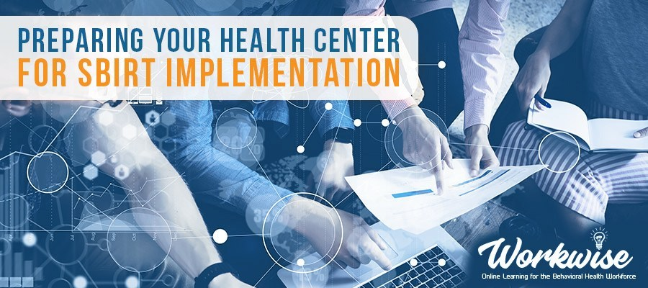

Screening, Brief Intervention, and Referral to Treatment (SBIRT) is designed to provide universal screening, prevention, and early intervention and treatment within health care settings and community-based organizations for people who have risky or hazardous alcohol and/or drug use.
Preparing your Health Center for SBIRT Implementation is a 7-week extended online learning series that will provide 15 hours of instruction for health-care providers establishing or currently implementing SBIRT in their agency. Through virtual, interactive learning, participants will receive real-time performance feedback related to their current use and implementation strategies of SBIRT with an emphasis on integrating brief interventions into current services and workflow.
WHEN: Every Tuesday, Sept 10 – Oct 22, 2019
10:00 – 11:30 a.m. (Pacific Time)

THIS TRAINING IS INTENDED FOR: Community Health Workers, Medical Assistants, Nurses and Behavioral Health Providers located in Nevada.

PARTICIPANT COMMITMENT & EXPECTATIONS
- Access to appropriate technology to utilize Zoom videoconferencing platform
  - View a 20-minute tutorial on how to use the Zoom videoconferencing platform
  - Attend a one-hour online Orientation
- Commit to 6-weeks of online training for 1.5 hours weekly on scheduled series days/times
- Complete weekly self-study learning activities

This is not a webinar series and active participation to gain/improve skills is required

THERE IS NO COST TO PARTICIPATE: The first 35 registrants will receive a waiver that covers the entire $350 cost of participation.
FOR QUESTIONS OR REGISTRATION INFORMATION: contact Wendy Woods at wwoods@casat.org or by phone at 775-784-6265 or 866-617-2816 (toll-free).
CONTINUING EDUCATION: This series has been approved for 15 contact hours through the following professional associations: NEVADA - Nevada Board of Examiners for Alcohol, Drug & Gambling Counselors; Nevada State Board of Nursing; Board of Examiners for Marriage and Family Therapists and Clinical Professional Counselors; State of Nevada Board of Examiners for Social Workers. NATIONAL - National Association for Addiction Professionals (NAADAC), International Certification & Reciprocity Consortium (IC&RC), and the National Board for Certified Counselors (NBCC) ACEP No. 6492.
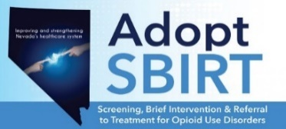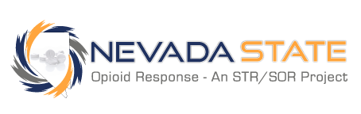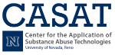
This publication was supported in whole or in part by the Nevada Division of Public and Behavioral Health Bureau of Behavioral Health, Prevention, and Wellness through funding provided by the Nevada State Targeted Response to the Opioid Crisis Grant (1H79TI080265-02) awarded by the Substance Abuse and Mental Health Services Administration (SAMSHA). The opinions, findings conclusions and recommendations expressed in this publication/program/exhibit are those of the author(s) and do not necessarily represent the official views of the United States Department of Health and Human Services, SAMSHA or the State of Nevada.

